**Hershey Little League**

**P.O. Box 702**

**Hershey, PA 17033**

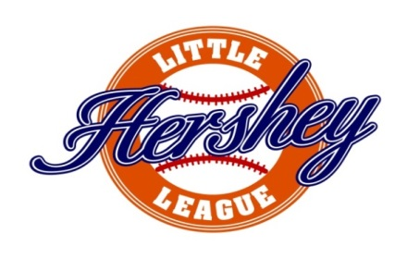

**2025 Sponsor Campaign Registration Form**

**Business Name – Please print** as it is to appear on the Uniform: ______________________________________

Address: ___________________________________________________________________________

City: ___________________________________________________________________________________

**Contact Person** for Advertising Information (logos, etc.):

Name: ___________________________________________________________________________________

Phone: ______________________________________________________________________________________

E-mail: _______________________________________________________________________________

Company Website: ________________________________________________________________________

Child’s Name for Sponsorship (not required) __________________________________

**Designate Team Level (place “X” for team Level designation)**

– T-Ball O – Colts O – Minors O – Majors O – Challenger’s O – Teeners O – All Stars

**TEAM Sponsorship Opportunities (place “X” for Selection)**

O - HOMERUN Sponsorship ($450) O – EXTRA BASE Sponsorship ($200)

**DIVISIONAL Sponsorship Opportunities (place “X” for Selection)**

O - TRIPLE Sponsorship ($750)

**REGISTRATION Sponsorship Opportunities (place “X” for Selection)**

O - DOUBLE Sponsorship ($500)

**CORPORATE Sponsorship Opportunities (place “X” for Level)**

O – PLATINUM Opening Weekend Ceremonies ($2,500) O – PLATINUM Instructional Clinics ($2,500)

O – SILVER Championship Weekend ($1,500) O – SILVER HomeRun Derby ($1,500)

O – COPPER Field Maintenance Team ($1,000)

**Sponsor Form and Check can be mailed to**: Hershey Little League (address above)

**Sponsorships can be made via Online at**: [www.hersheylittleleague.net](http://www.hersheylittleleague.net)

On behalf of HLL, we **Thank You** in advance for your generosity and ongoing support!

If you are interested in other sponsorship opportunities to include, but are not limited to:

Youth Clinics, Team Equipment, Team Equipment bags, Field Equipment, Field Supplies, Opening Ceremony Raffle/Giveaways or specific field capital improvement projects, please contact HLL directly for further information.

*Any events and signage are subject to Derry Township and Derry Township School District approvals, where applicable